**Name -: Aditya Babaso Birangaddi**

**Roll No -: 47**

**Enrollment No -: 1915770160**

**Practical No 4**

**Q 1] Write a program to check whether a number is even or odd**

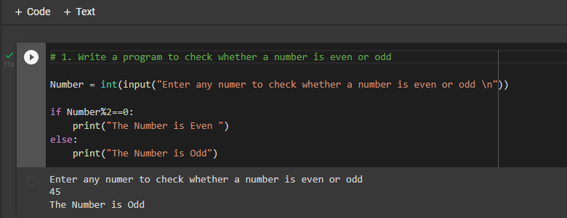

**Q 2] Write a program to find out absolute value of an input number**

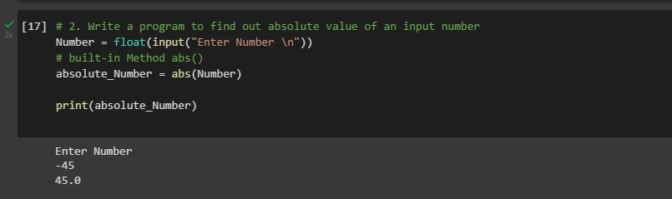

**Q3] Write a program to check the largest number among the three numbers**

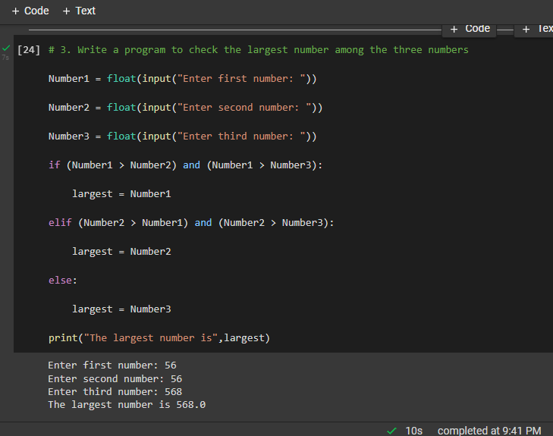

**Q4] Write a program to check if the input year is a leap year of not**

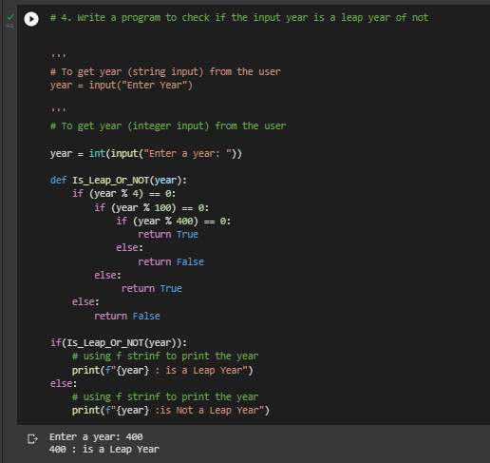

**Q5] Write a program to check if a Number is Positive, Negative or Zero**

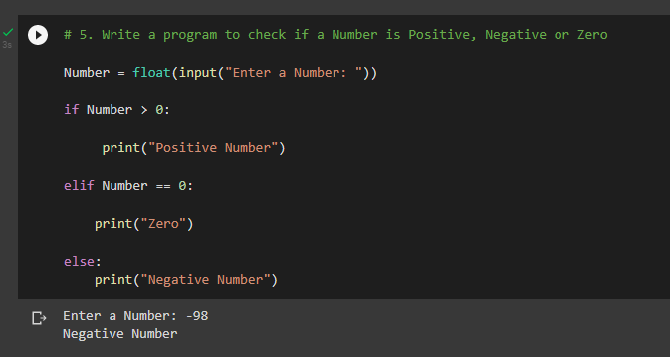

**Q6] Write a program that takes the marks of 5 subjects and displays the grade.**

